Writing Easy

<__question>

Type=2

<__block>

For this part you are allowed 20 minutes. Describe the picture and the scene.  Pretend you are there.  What are you doing?  How do you feel?  Who are you with?  What can you hear?  What can you see and smell?  What memories do you have?  Use at least 15 adjectives and 10 adverbs.  Use strong verbs.  Use a simile and a metaphor.  Make your writing interesting.

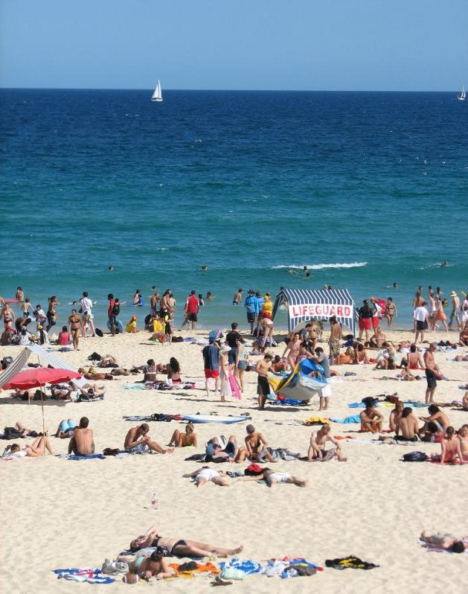

<__block>

some answer in here

<__question>

Type=2

<__block>

For this part you are allowed 20 minutes. Describe the picture and the scene.  Imagine you are a person on the grass.  Why are you here?  How do you feel?  What are you thinking about?  What is happening around you? Use at least 10 adjectives and 5 adverbs.  Use strong verbs.  Use comparisons. Make your writing interesting.

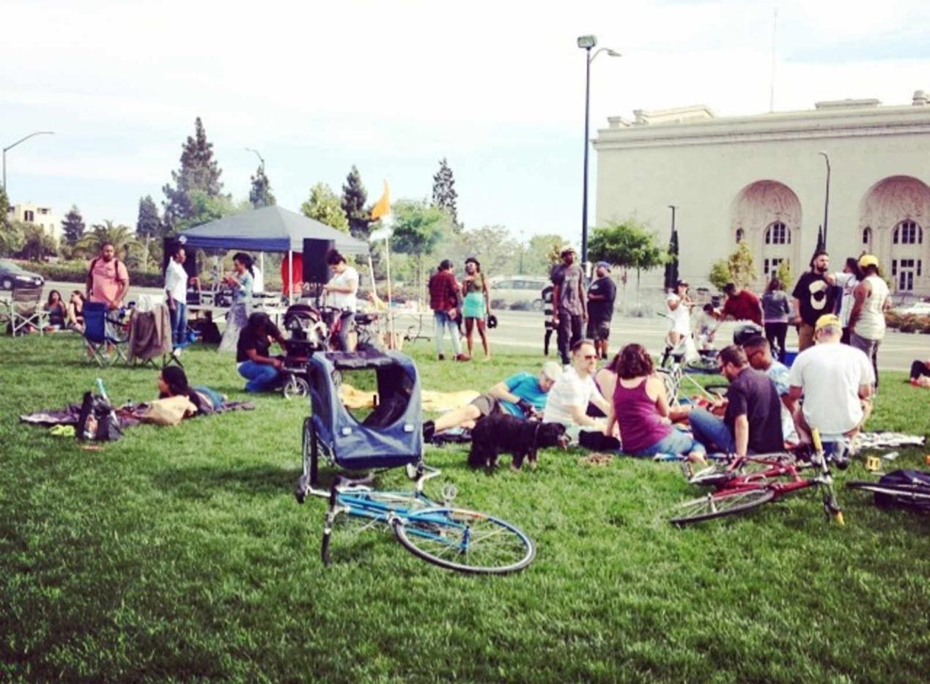

<__block>

some answer in here

<__question>

Type=2

<__block>

For this part you are allowed 20 minutes. Imagine you are one of the people in this photo. Where are you going and what are you doing? What will you do after this? What are you feeling and why? What did you do before this? Who are the other people and how well do you know them? Use comparative and superlatives in your writing. Make suggestions about what they people should do. Make your writing interesting.

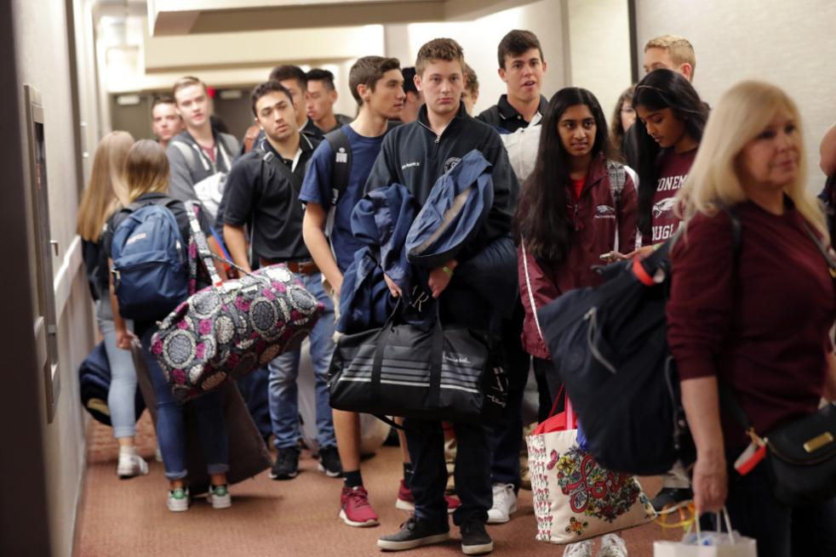

<__block>

some answer in here

<__question>

Type=2

<__block>

For this part you have 20 minutes. Look at the picture and describe it. Write about 5 of the people in the picture. What are they doing and why do you think they are there? Talk about their feelings and motivations for being in this photo. Use 5 adjectives and descriptive language. Use your imagination to make this picture part of a bigger story of their lives. If you could meet one of the people in this photo, who would it be and why?

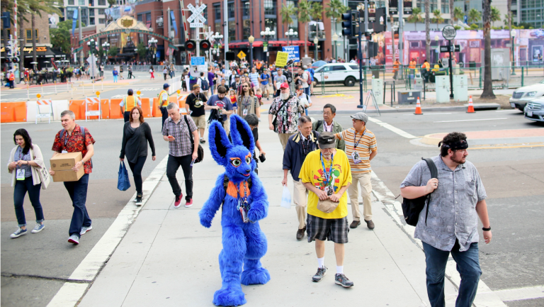

<__block>

some answer in here

<__question>

Type=2

<__block>

For this part you are allowed 20 minutes. Describe the picture and the scene.  You are one of the people in this photo. Who are you with and how do you feel?  What did you buy and who is it for? How much does it cost? Is it something special? Do you usually shop and what do you buy? Tell an interesting story about shopping. Use at least 5 adjectives and 5 adverbs.  Use strong verbs.  Use a simile and a metaphor.  Make your writing interesting.



<__block>

some answer in here